AWS VPC Task

- Create VPC with 2 private and 2 public subnets
So we can create a new VPC in the AWS console with giving the proper IP
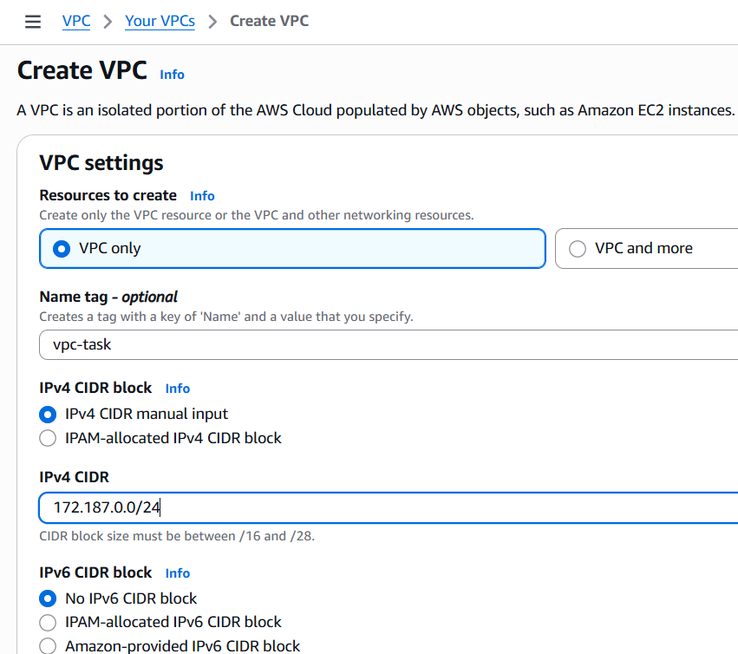
So, As you can see the IP has been created
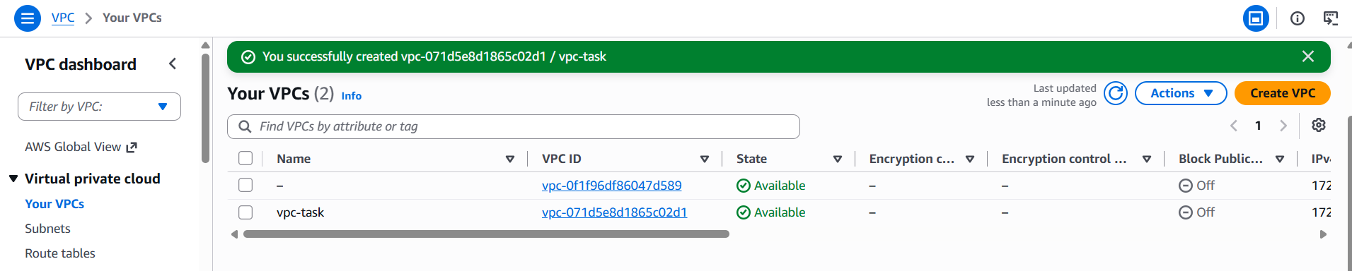
And I created 2 public and 2 private subnets
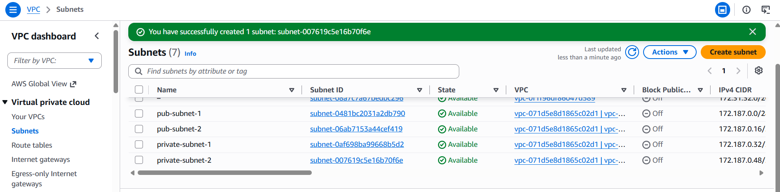

- Enable DNS Hostname in VPC.
Select the VPC and click on Actions, there you can see the Edit VPC settings
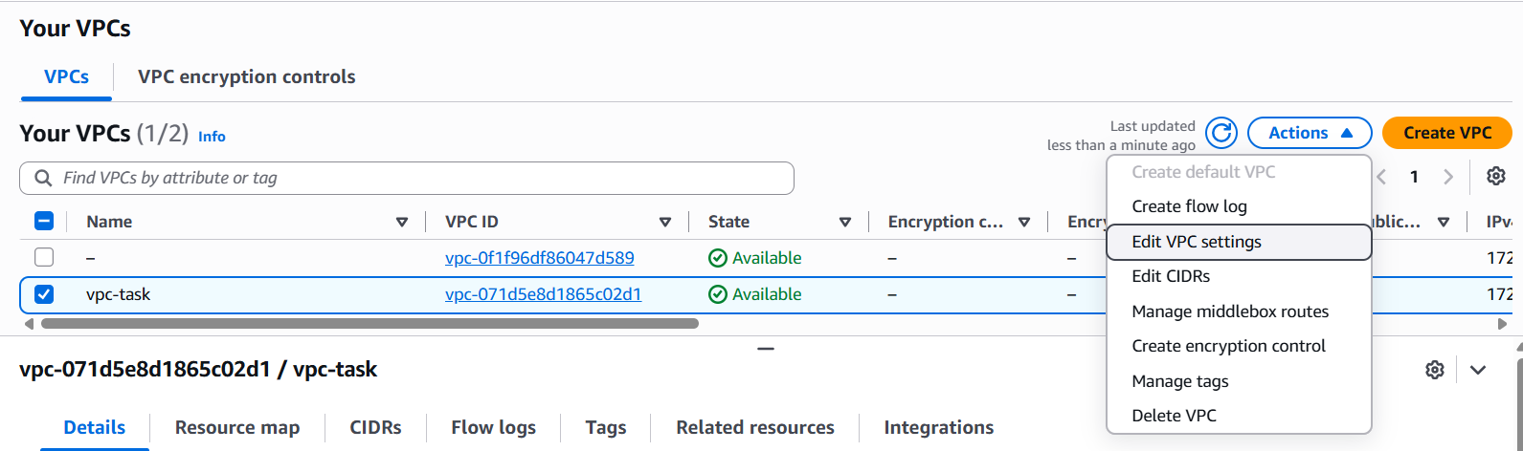
Below, you just want to enable DNS hostnames and save it.
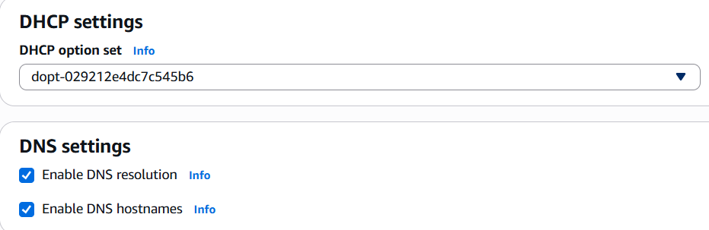

- Enable Auto Assign Public IP in 2 public subnets.
First go to the subnets and select on the first public subnet and open action, There you can see the Edit subnet settings, there you can enable the auto-assign IP settings. Do the same for the public IP-2
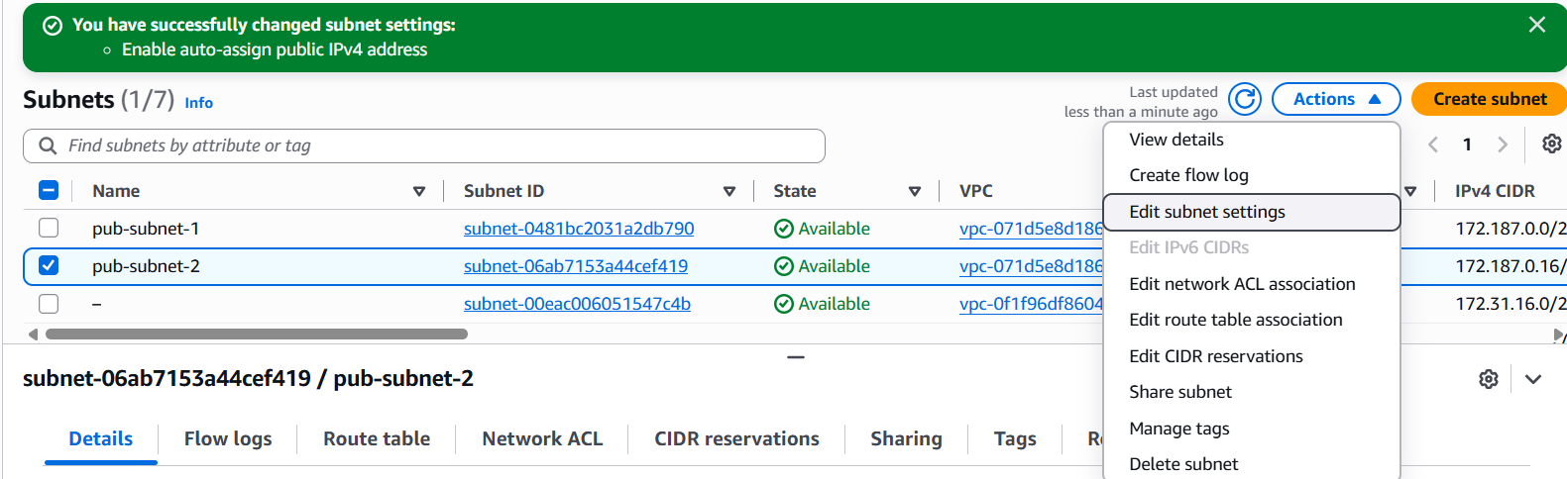
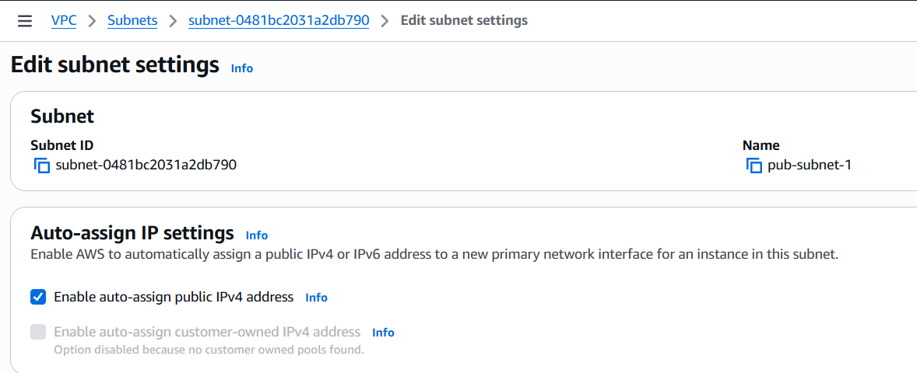
- Add 2 private subnets in private route table.
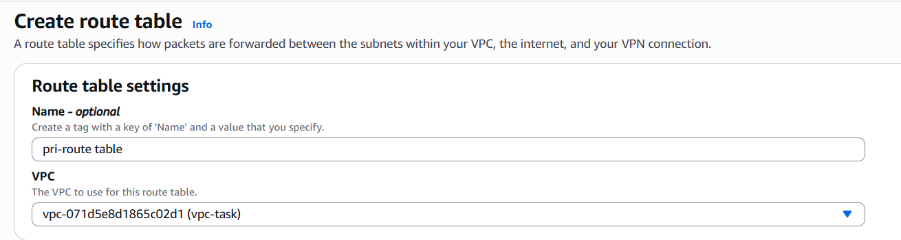
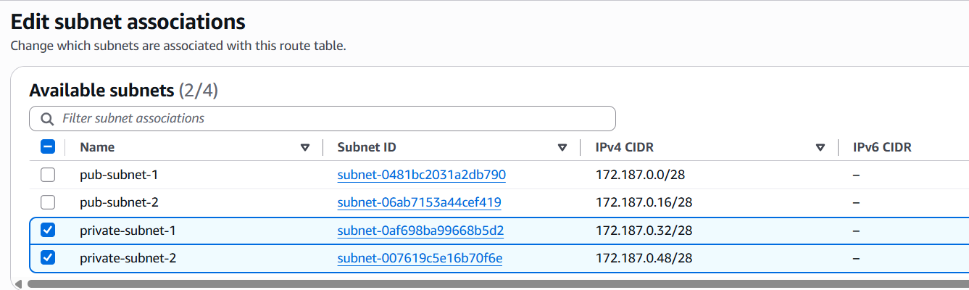
- Add 2 public subnets in public route table.
Do the same steps as above, but add the public subnet instead
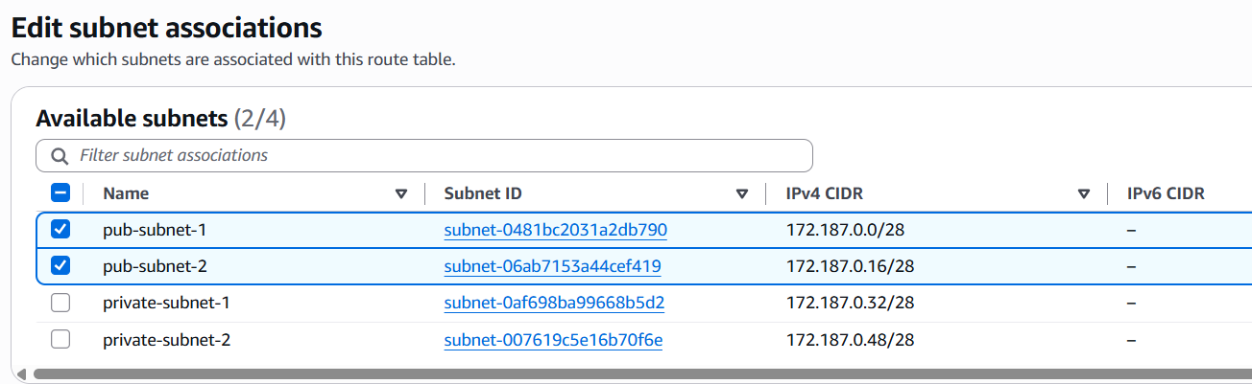
- Public route table will have the routes to internet and local.
Create internet gateway and add VPC to your internet gateway, You can see its created
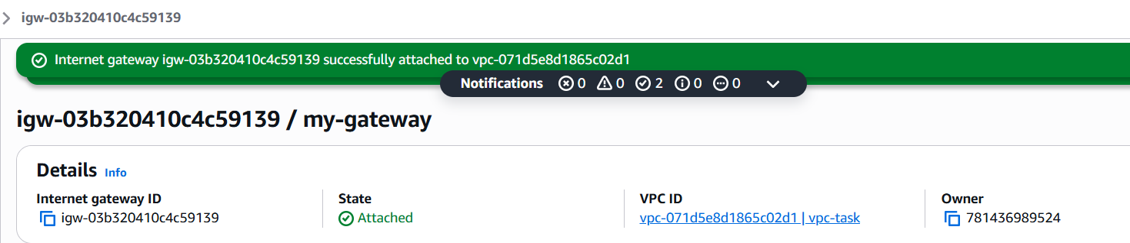
Here, Go to Routes tab below and create a new one with internet gateway and in the drop down select mygateway, it will be added
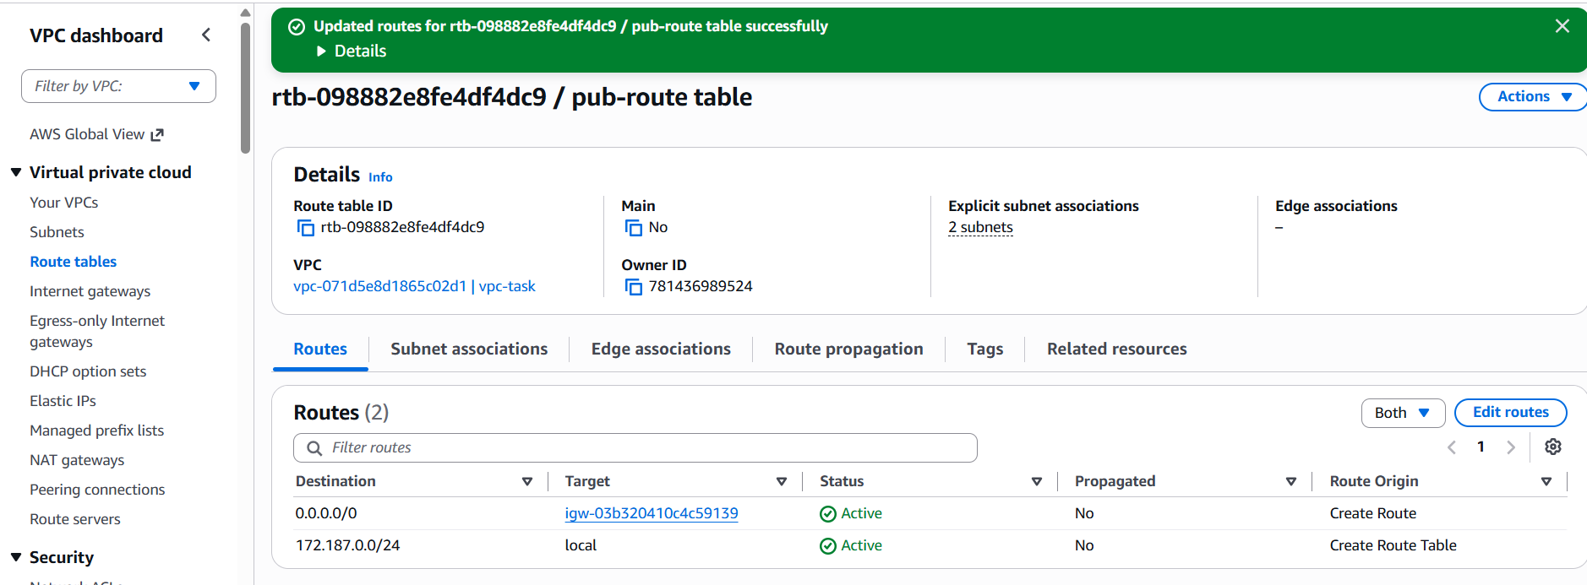
- Create EC2 in public subnet with t2.micro and install PHP.
Create a instance with the name php-server and select amazon linux image and select your VPC and select your public subnet and launch the instance
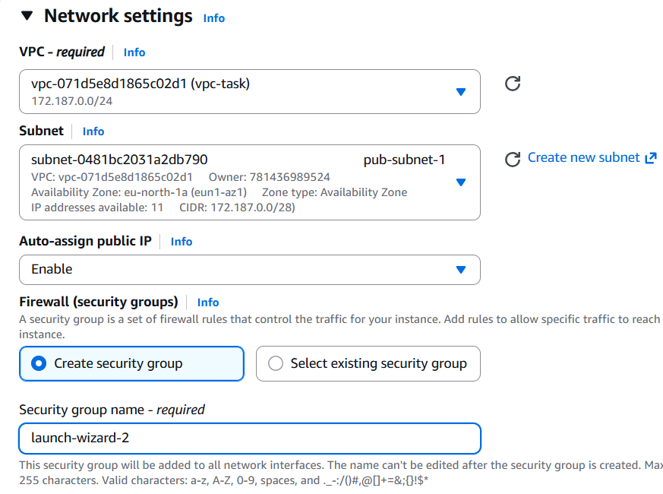
Write the installation code of PHP in the user data and launch the instance
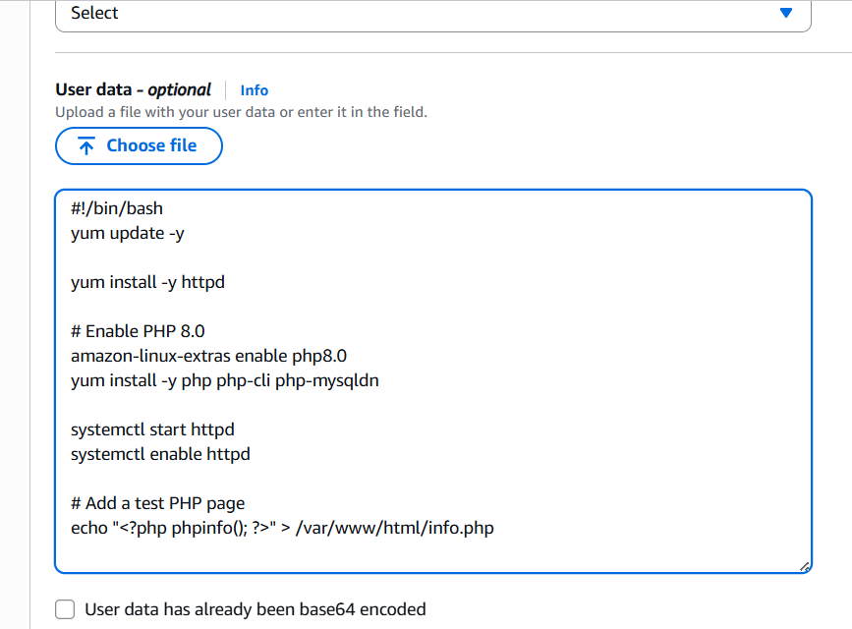
I launched the instance and I connected to that instance, I can see the status of httpd , its running
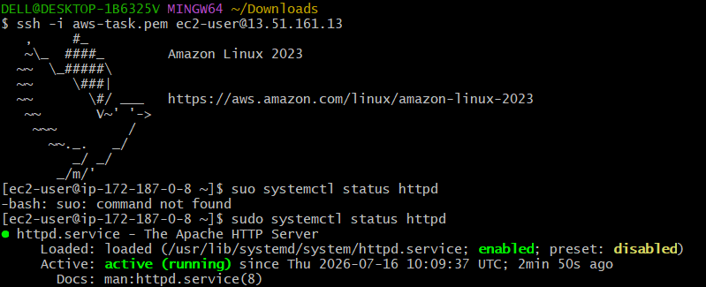

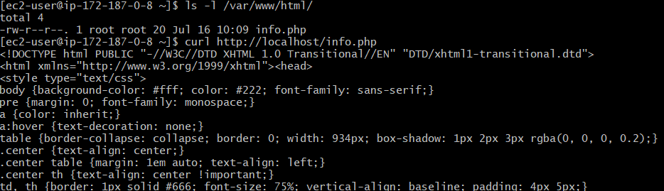
Open browser and check with the http://ipadress/info.php
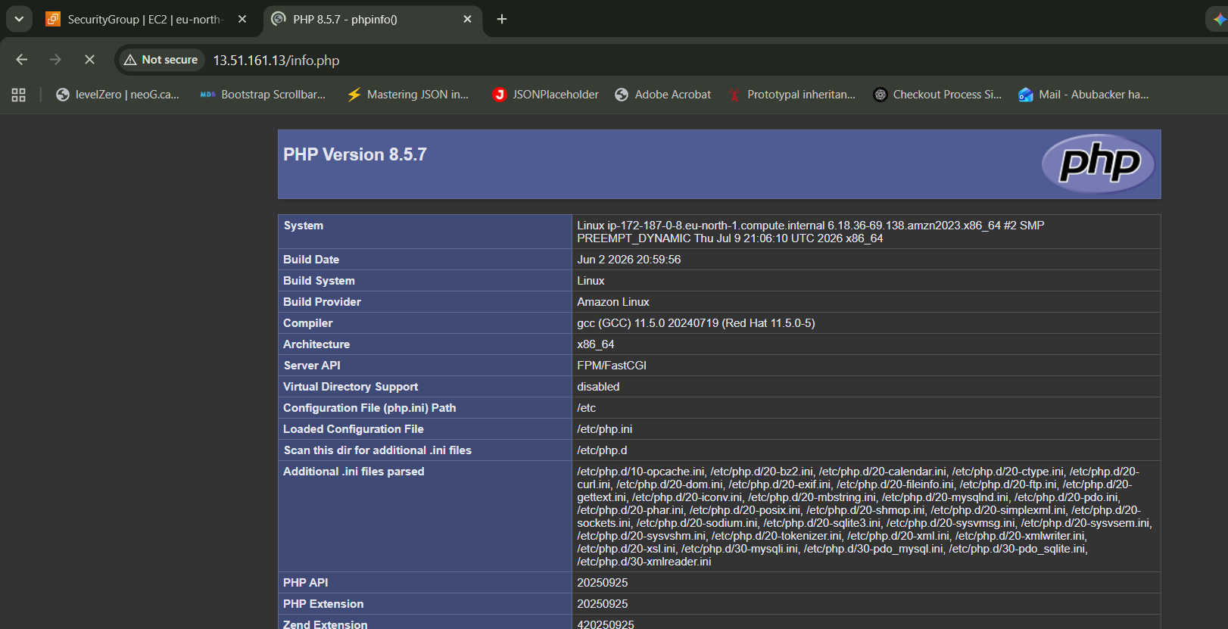
- Configure NAT gateway in public subnet and connect to private instance.
Create a NAT gateway, Open the route table and add the NAT gateway which created
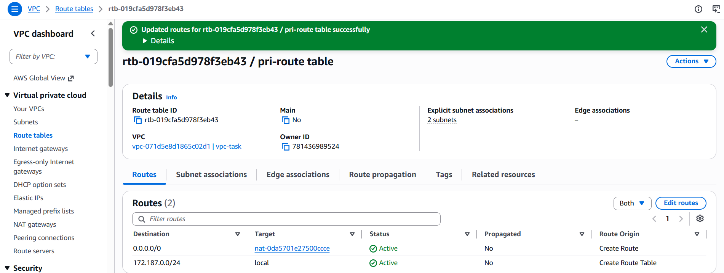
Copy the PEM key and login to public instance, Create a new .pem file and paste the key there and give 600 permissions to make it work
And connect to private instance through the new pem key and the private IP of the private instance
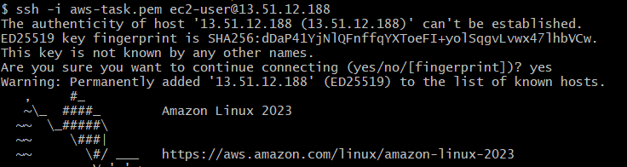
The instance has been created and I checked for the internet connectivity as well. Its working fine
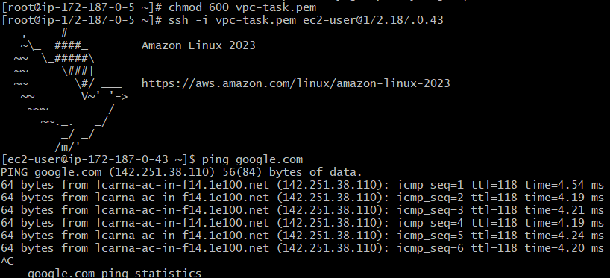

9. Install Apache Tomcat in private EC2 and deploy a sample app.
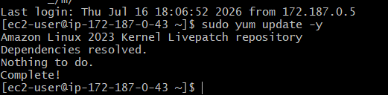
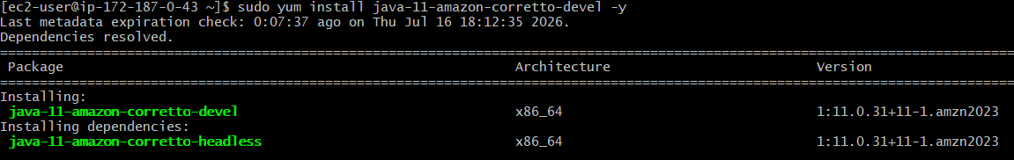
wget https://dlcdn.apache.org/tomcat/tomcat-9/v9.0.120/bin/apache-tomcat-9.0.120.tar.gz
tar -xf apache-tomcat-9.0.120.tar.gz
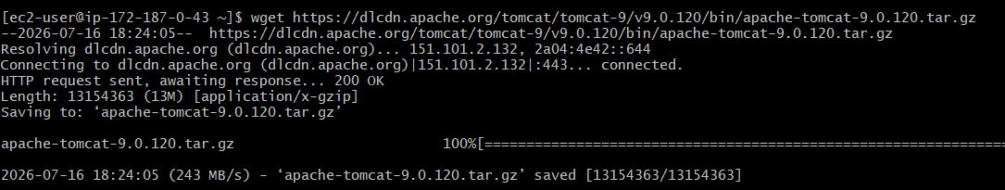
sh /opt/tomcat/bin/startup.sh
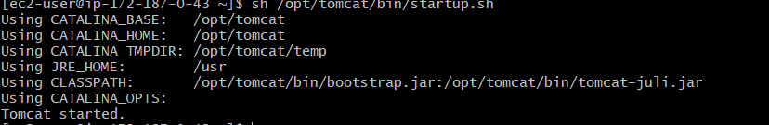
To deploy the sampe apps
wget https://tomcat.apache.org/tomcat-9.0-doc/appdev/sample/sample.war
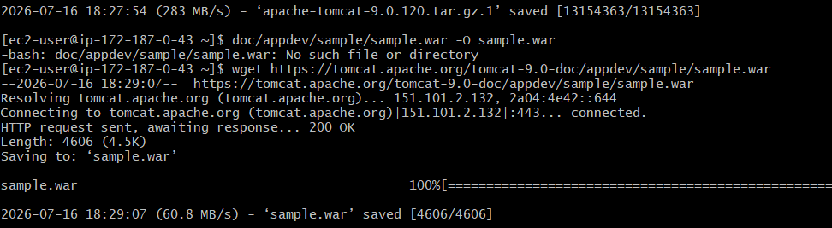
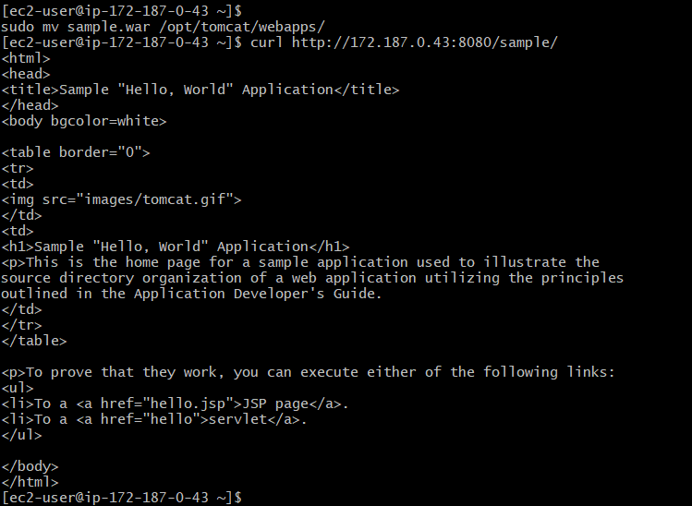
I checked it with the curl http://<Private IP>:8080/sample/
It works

10. Configure VPC flow logs and store the logs in S3 and CloudWatch.
For the flow logs, we should have VPC and then click on create flow logs
We can either create through Cloudwatch or S3 bucket, First I am going with cloudwatch
For that we need to create IAM role and add that IAM role to cloudwatch
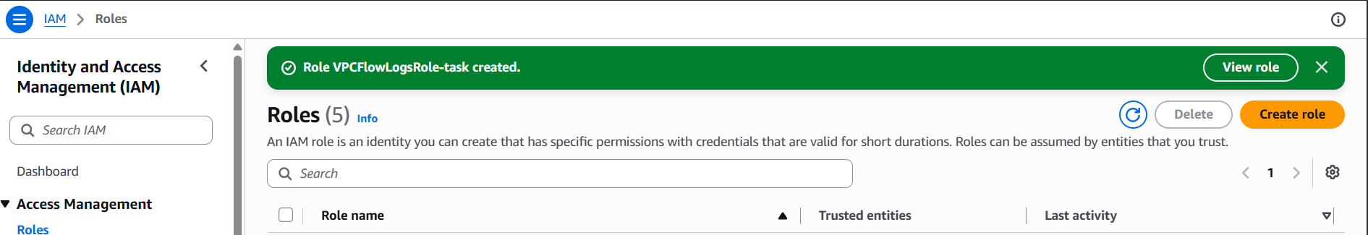
So here you can see that it has been created using cloud watch
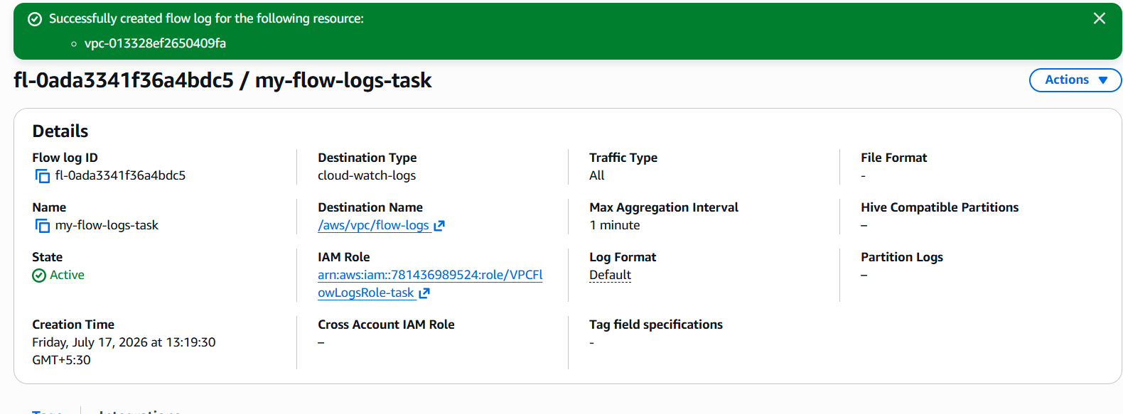
Here I have created a flow logs using S3 bucket, First I created a S3 bucket and addded that ARN ID to the flow logs and create it, it will get created.
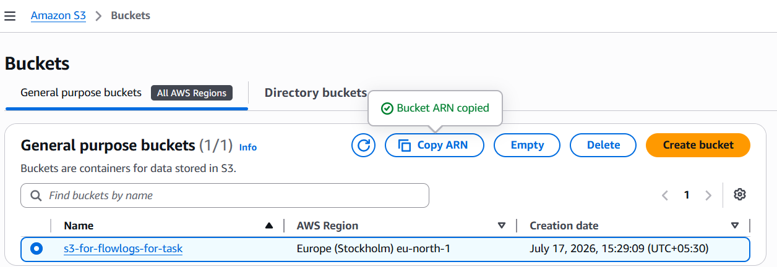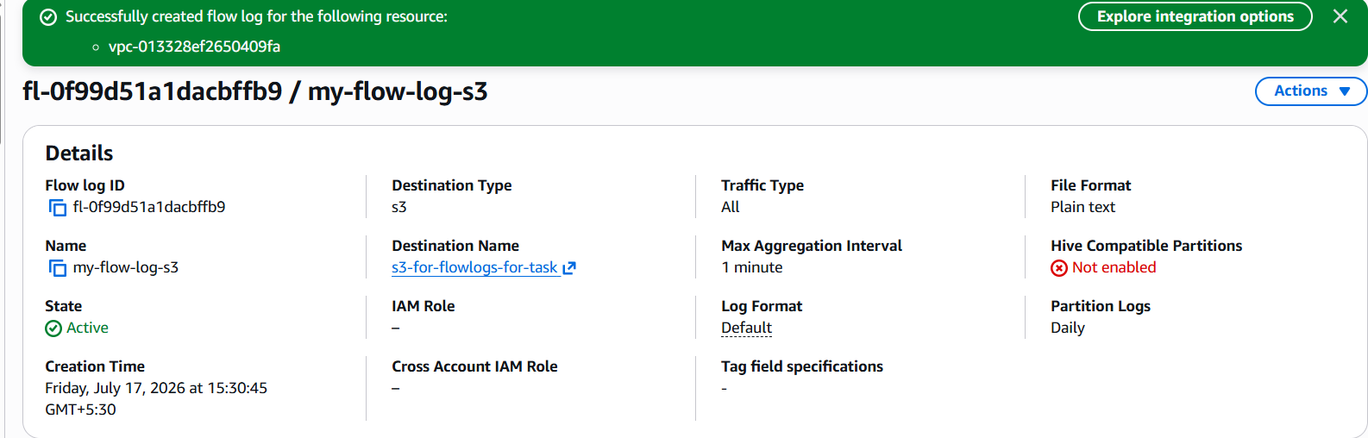
Below you can see, In the VPC flowlogs tab, 2 flow logs has been created.
